**Comp 3710 Assignment 1 – Temperature Converter**

The app has two edit text boxes and two buttons. The edit text boxes are so the user can input either a temperature in Fahrenheit or Celsius. Once the user has typed in the temp, the app will convert it either into Fahrenheit or Celsius.

The edit text boxes are named txtF for Fahrenheit and txtC for Celsius. The txtF box has a label that says, “Temperature in F”. The txtC box has a label that says, “Temperature in C”.

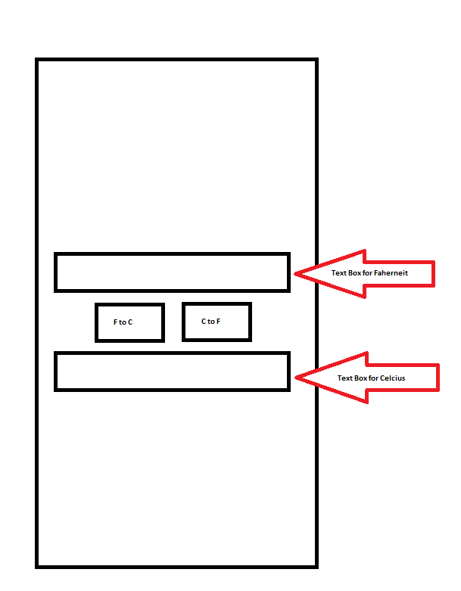The Buttons are called btnConvertF2C and btnConvertC2F. Both buttons once clicked will do a conversion of the temperature based on if the user wans Fahrenheit or Celsius.

**Example of the User Interface:**